GTB  
  
**QA**  
[DEV 20.22] OT-844 | XT | DE | AS | Send to Dealer Popin v1 – 05 June 2020

**Jira ticket:**  
<https://jira.uhub.biz/browse/GTBEMEAOPT-877>

**Site**  
<https://www.ford.de>

**Test location**  
All pages except on BnP and Send to Dealer page

**Hypothesis**  
Analysis on the TDR Popin and UC5 has shown that TDR Popin converts at a higher rate than UC5 for TDR Completes. We know that we can expect the conversion rate to be 100% higher than onsite conversion. As such, we want to ensure we keep leveraging this popin and its audience even during the pandemic. However, we will be shifting our focus to "Contact Us" to maintain a touch-free approach.

**Test Description**

View the “BnP Start and Finish” link. Click the “Konfigurator” link at the top of the page in the main header. On the next page select any vehicle by clicking on them.  
  
Once you’re done the above view the “Only on profile script true” link. A popup should’ve appeared after 10 seconds. If the vehicle is on the Send to Dealer page exactly as you’ve chosen it. I.E. if like in the bottom images you selected the Ford Edge Vignale and you clicked on the “Konfiguration an Händler senden” button, it would take you to a page deep linked into that vehicle, meaning you’d get on a page with that vehicle as the main focus.

If the vehicle you chose isn’t on that page exactly, you would instead see the generic page with the user being able to pick the vehicle he wants before continuing. For example, if you chose the Ford Fiesta Trend, there isn’t a Ford Fiesta Trend option on that page. It would show the generic page. The generic page is the “Send to Dealer Link” that I’ve attached below.

A deep linked version would be something like this: <https://www.ford.de/content/overlays/wizard-overlays/s2d?vehicleCode=00E-YBT>   
This is specifically for the Ford Edge Vignale.

The popup should look something like this, with the 3 mini popups to follow after:

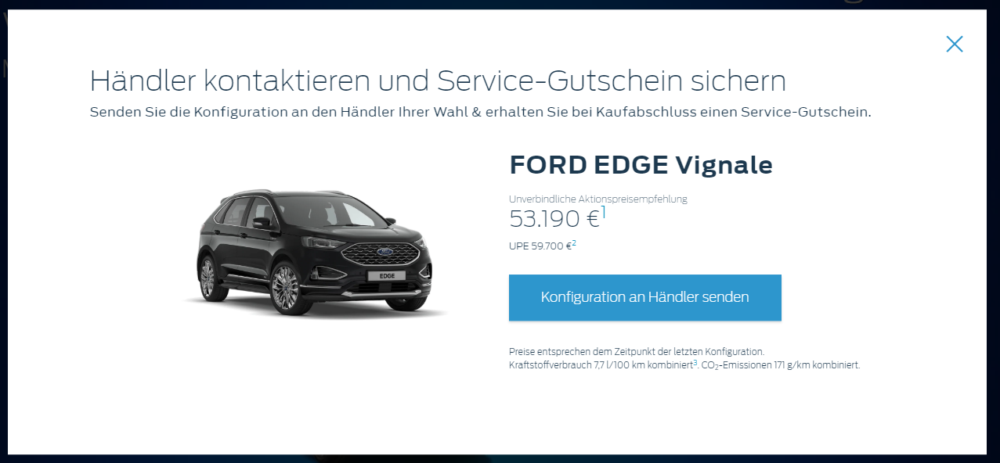

First Popup:

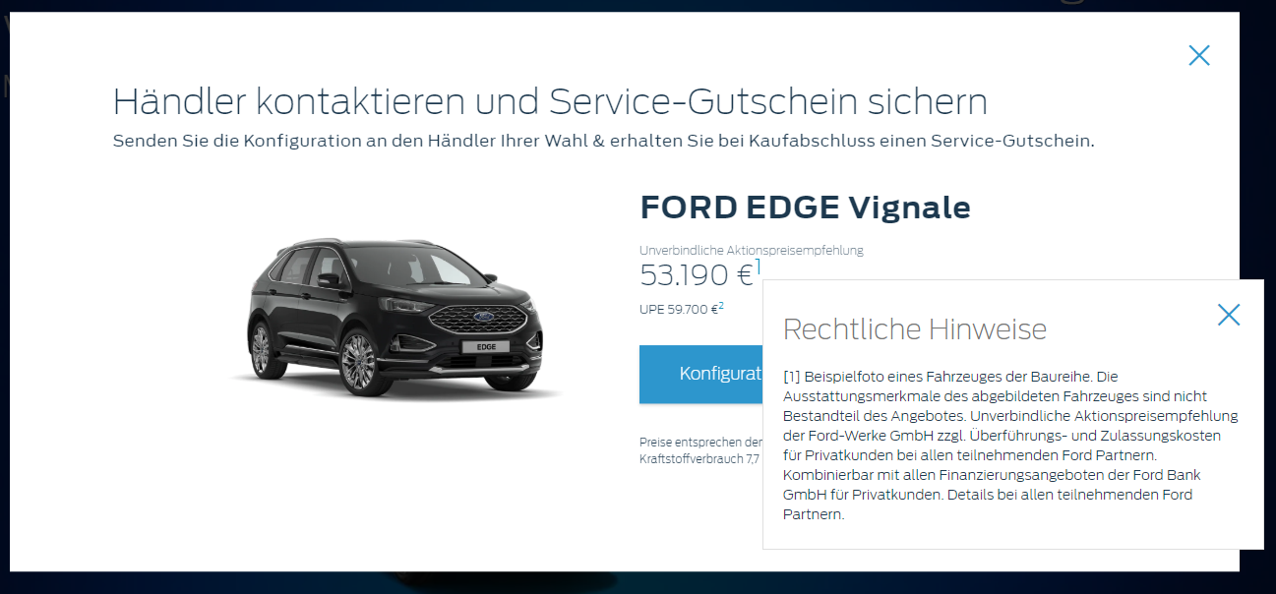

Second Popup:

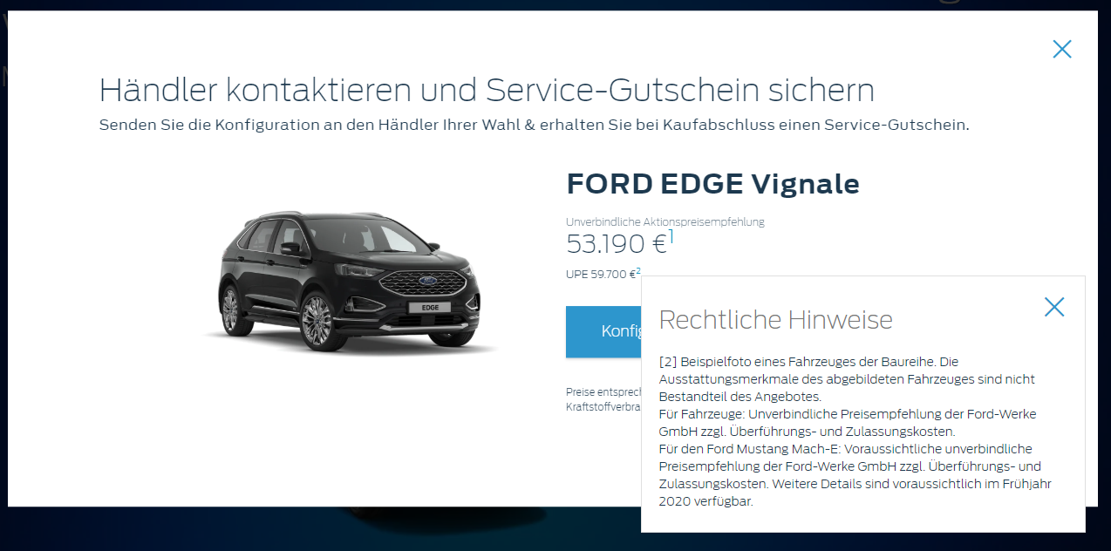

Third Popup, note that this one has a scroll so that you can view all the content:

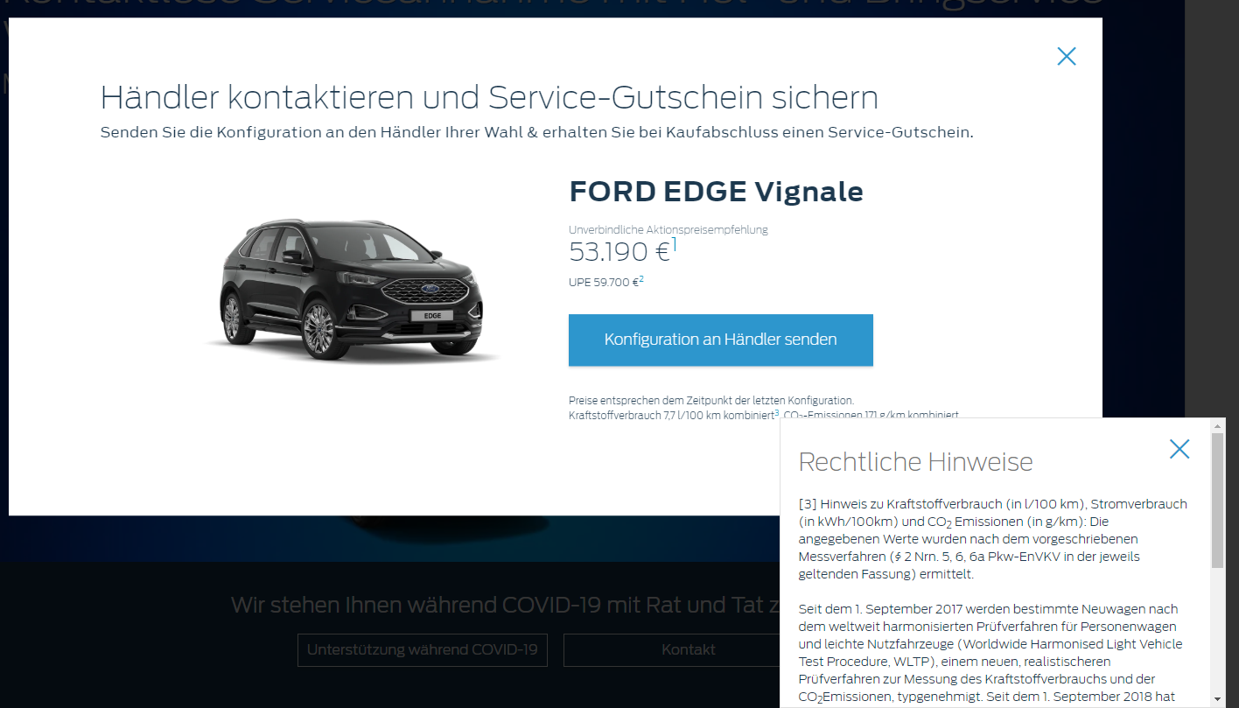

Lastly if this all works, there is one final thing to test. Go back to the BnP Start and Finish link and follow those instructions until you’re on the selected vehicle. Then click on the blue button in the top right that says “Zusammenfassung & nächste Schritte” on the next page click on the white button that says “Konfiguration an Händler senden”. Once you’ve done this, open the “Only on profile script true” link again. There shouldn’t be a popup for that vehicle.

**Browser:**   
All  
  
**Device:**   
All  
  
**Audience rules:**   
All traffic

**QA Links:**

**BnP Start and Finish**

<https://www.ford.pl?at_preview_token=UERlGec3uFk46XPb1TZbzQ%3D%3D&at_preview_index=1_1&at_preview_listed_activities_only=true>

**Only on profile script true**

<https://www.ford.pl?at_preview_token=UERlGec3uFk46XPb1TZbzQ%3D%3D&at_preview_index=1_2&at_preview_listed_activities_only=true>

**Send to Dealer**

<https://www.ford.de/content/overlays/wizard-overlays/s2d>